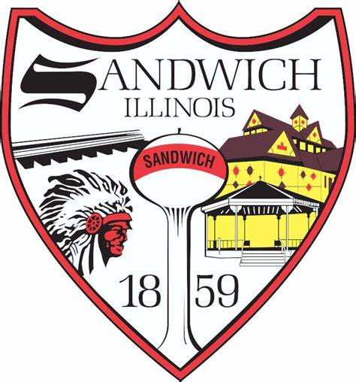
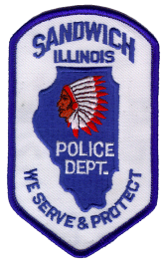
City of Sandwich
Board of Police and Fire Commission
February 29th 2024
6:00PM

- Call to order
- Roll Call
- Public Comment
- Correspondence
- Open Business
- Approval of minutes 12-6-2023
- Approval of Meeting Dates 2024
- Establishing an Eligibility List
- New Business
- New Candidate Interviews
Executive Session 5/ILCS 120/2 (c ) (1) for the appointment, employment, compensation, discipline, performance, or dismissal of specific employees.
- Adjournment

