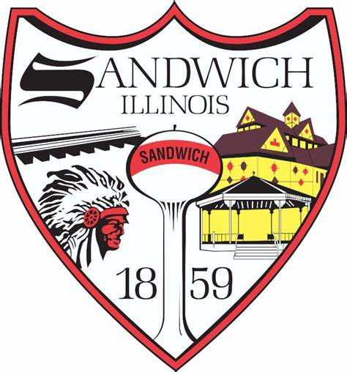
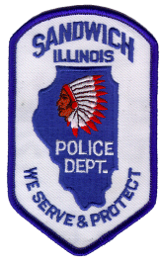
City of Sandwich
Board of Police and Fire Commission
March 2nd, 2024
9:00AM

- Call to order
- Roll Call
- Public Comment
- Correspondence
- Open Business
- Establishing an Eligibility List
- New Business
- New Candidate Interviews
Executive Session 5/ILCS 120/2 (c ) (1) for the appointment, employment, compensation, discipline, performance, or dismissal of specific employees.
- Adjournment

